# Manuscript Preparation Instructions for 2024 SNDCT (Title in 18-point Times font)

First name Lastname1, First name Lastname2, and First name Lastname3

(List authors on this line using 12 point Times font – use a second line if necessary)

### 1Affiliation, Country, 2Affiliation, Country, 3Affiliation, Country

### (Authors' affiliation(s) listed here in 12 point Times font – use a second line if necessary

### *Abstract* — Please prepare your manuscript based on the format instructions detailed in the template. Manuscripts which obviously violate the format instructions will be rejected automatically. Use 9 point Times New Roman Bold font for the abstract.

### *Index Terms* — Transistors, ceramics, coaxial resonators, delay filters, delay-lines, power amplifiers (Use the alphabetical order).

### I. Introduction

Authors should submit papers in PDF format. Paper size is A4. Please read through this entire template carefully before you start using it to create your paper! The maximum length of the abstract is 1 page including text and figures/tables. The accepted papers will be published in the Proceedings without any changes. **Do not** number the pages.

### II. Detailed Text Formatting

For the Title use 18-point Times (Roman) font. Its paragraph description should be set so that the line spacing is single with 6-point spacing before and 6-point spacing after (Format --> Paragraph --> Indents and Spacing). The font description for the Author List and Authors' Affiliation(s) should be 12-point Times. The paragraph descriptions should be set so that the line spacing is single with 6-point spacing before and after. Use an additional line spacing of 12 points before the beginning of the double column section, as shown above

Using A4 paper (210 mm  297 mm), the top & bottom margins should be 2.59 cm (1.02") and left & right margins should be 1.42 cm (0.56") with .48 cm (.19") between columns.

Each major section begins with a Heading in 10 point Times font centered within the column and numbered using Roman numerals (except for Acknowledgement and References), followed by a period, a single space, and the title using an initial capital letter for each word. The remaining letters are in small capitals. The paragraph description of the section heading line should be set for 6 points before, 6 points after, and the line spacing should be set to exactly 12 points.

For the body of your paper, use 10-point Times font and set your line spacing at "exactly 12 points" with 0 points before and after. Indent each paragraph by 0.125 inches.

*A. Major Subsections*

As shown, denote subsections with left justified 10-point times Italic. Order them with capitalized alphabetic characters (*A, B,...*). Follow the letter designation with a period, a single space, and then the subsection title capitalizing the first letter of each word. The paragraph description of the subsection heading is set to "exactly 12-point" line spacing with 6 points before and after.

*B. Equations*

Equations should be centered in the column and numbered sequentially. Place the equation number to the right of the equation within a parenthesis.

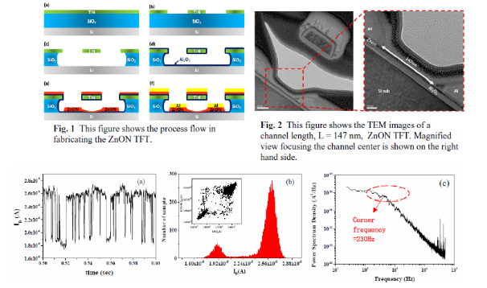

*Fig. 1* (a) 2-level ID RTN time domain signal, (b) the histogram of current fluctuation, where the inset is time lag plot of the measured RTN, and (c) measured results of a 2-level Id RTN frequency domain signal.

III. Conclusion

Summarize your work here.

### References

[1] W. H. Cantrell, “Tuning analysis for the high-*Q* class-E power amplifier,” *IEEE Trans. Microwave Theory & Tech.,* vol. 48, no. 12, pp. 2397-2402, December 2000.

[2] W. H. Cantrell, and W. A. Davis, “Amplitude modulator utilizing a high-Q class-E DC-DC converter,” *2003 IEEE MTT-S Int. Microwave Symp. Dig.*, vol. 3, pp. 1721-1724, June 2003.

[3] H. L. Krauss, C. W. Bostian, and F. H. Raab, *Solid State Radio Engineering*, New York: J. Wiley & Sons, 1980.

[4] K. Elissa, “Title of paper if known,” unpublished.

[5] R. Nicole, “Title of paper with only first word capitalized,” *J. Name Stand. Abbrev*., in press